
KING SALMAN
INTERNATIONAL UNIVERSITY
FACULTY OF COMPUTER SCIENCE
AND ENGINEERING

CSC491 - GRADUATION PROJECT
Project Title
EGX360: Intelligent Stock Market
Analysis and Forecasting Platform
A Thesis Submitted To Computer Science Department
Faculty of Computer Science and Engineering, KSIU

In Partial Fulfillment of B.Sc. Degree in Computer Science Program
By
Mohamed Taher Amin
Supervisors
Dr. Samy Abdelnabi
Associate Professor, Faculty of Computer Science
King Salman International University

EGYPT, 2026

ACKNOWLEDGEMENT

I would like to express my sincere thanks to my supervisor, Dr. Samy Abdelnabi, for his continuous guidance and help throughout this project. I also want to thank Eng. Abdelaziz Hussein for his support, effort, and valuable advice which helped me a lot in completing this work.
Special thanks to the Faculty of Computer Science and Engineering at King Salman International University for providing the required resources and a great learning environment.

ABSTRACT

This thesis presents EGX 360, an AI-driven FinTech platform designed to mitigate volatility and data fragmentation in the Egyptian Exchange (EGX). The study demonstrates that integrating macroeconomic features (USD/EGP, gold, interest rates) with a Stacking Ensemble architecture (XGBoost & LightGBM) significantly enhances prediction accuracy. By utilizing Target Engineering (EMA10 direction), the model achieved an 85.22% accuracy and 80% down-trend recall on 28 years of data, yielding a +159% alpha over the market baseline.
The ecosystem utilizes a scalable AWS and Supabase backend with autonomous scrapers and real-time WebSocket streams. It features an advanced bilingual NLP sentiment pipeline and a cross-platform Flutter frontend built on Feature-First Clean Architecture. Key functionalities include interactive charting, a Cerebras API Llama 3.1-powered AI assistant, a paper-trading simulator with a dynamic Guardian Engine for risk management, and a social trading community. Ultimately, EGX 360 provides a production-ready environment for independent investors to achieve data-driven financial autonomy.

LIST OF FIGURES

Figure ‎1.1 The future vision for agriculture [6]. 1
Figure ‎1.2 Types of Agriculture Robots 1
Figure ‎2.1 Solar-powered Agriculture Robot Design [2] 4

LIST OF TABLES

Table ‎1.1 Properties of Stainless Steel 2

LIST OF SYMBOLS

TABLE OF CONTENTS

ACKNOWLEDGEMENT I
ABSTRACT II
LIST OF FIGURES III
LIST OF TABLES V
LIST OF SYMBOLS VII
TABLE OF CONTENTS IX
1. CHAPTER 1: INTRODUCTION 1
1.1. Introduction 1
1.2. Problem Statement 2
1.3. Objectives 2
1.4. Project Scope 3
2. LITERATURE REVIEW 4
2.1. Financial Prediction Methods Overview 5
2.2. Sentiment Analysis and NLP in Finance 6
2.3. Emerging Markets vs Developed Markets 7
2.4. Risk Management in Automated Trading 8
3. SYSTEM DESIGN & ARCHITECTURE 7
3.1. Requirements (Functional & Non-Functional) & Use Cases Diagram 7
3.2. High-Level Architecture Diagram 7
3.3. Database Schema and Conceptual Data Model 7
3.4. Technology Stack Selection 7
3.5. System Data Flow 7
4. BACKEND INFRASTRUCTURE & DATA ENGINEERING 10
4.1. Data Sourcing & Scraper Engineering 10
4.1.1. EGX Data via Reverse Engineering 12
4.1.2. Real-Time Crypto Streaming (Non-Persistent) 12
4.1.3. Local Commodities & Market Summary Scraper 12
4.1.4. Autonomous News Scraping & Anti-Bot Strategies 12
4.2. Data Processing & NLP Pipeline
4.2.1. Text Cleaning & Metadata Extraction 12
4.2.2. Arabic Sentiment Analysis (Cerebras & Llama 3.1) 12
4.2.3. English Sentiment Analysis (FinBERT) 12
4.3. Database Architecture & Security
4.3.1. Unified Entity-Relationship Diagram (ERD) Strategy 12
4.3.2. Database Optimization (Normalization, Indexes, & Triggers) 12
4.3.3. Encrypted Virtual Wallet & Transaction Ledger 12
4.3.4. Security & Row Level Security (RLS) & Policies 12
4.3.5. Supabase RPCs (Advanced Analytics) 12
4.4. Authentication & User Access Control
4.4.1. OAuth 2.0 & Social Integration 12
4.4.2. SMTP Relay & Deep-Linking 12
4.4.3. Secure User State Management 12
4.5. Cloud Orchestration & Automation
4.5.1. AWS EC2 Deployment & Environment Setup 12
4.5.2. Automated Daemons & Market Status Tracker 12
4.5.3. Guardian Engine (Risk Management Logic) 12
5. INTELLIGENT PLATFORM SERVICES 13
5.1. Intelligent AI Chatbot & Financial RAG Engine
5.1.1. LLM Orchestration (Cerebras API) 12
5.1.2. Semantic Retrieval & Portfolio Context Awareness 12
5.1.3. Real-Time Data Injection Pipeline 12
5.1.4. Chat Session Memory & Persistence 12
5.2. Social & Real-Time Interaction Infrastructure
5.2.1. Community Feed & Live Chat 12
5.2.2. Supabase Storage & Object Management 12
5.2.3. Content-User Linking 12
5.2.4. User Sentiment & Crowdsourced Analysis 12
5.3. Unified Notification & Analytical Event System
5.3.1. Firebase Cloud Messaging (FCM) Integration 12
5.3.2. Scraper & Analytics Triggers 12 5.3.3. Portfolio Watchlist-Driven Alerts 12
6. QUANTITATIVE AI MODEL DEVELOPMENT 13
6.1. Market Randomness & Target Engineering 13
6.1.1. The Random Walk Challenge in EGX30 12
6.1.2. Market Noise Extraction & SNR Analysis 12
6.1.3. EMA10 Direction Target Engineering 12
6.2. Advanced Feature Engineering & Macro Integration 13
6.2.1. Technical Indicators & Momentum Metrics 12
6.2.2. Egypt-Specific Macro Features (USD/EGP, Gold, Interest Rates) 12
6.2.3. Temporal Features & Cyclic Time Encoding 12
6.3. Model Architecture & Ensemble Strategy 13
6.3.1. Baseline Model: LSTM Network Architecture 12
6.3.2. Production Model: Stacking Ensemble Framework 12
6.3.3. Base Learners (XGBoost & LightGBM) & Meta-Learner Integration 12
6.3.4. Hyperparameter Optimization via Optuna Bayesian Search 12
6.4. Model Evaluation & Financial Backtesting 13
6.1.1. Training Strategy & Time Series Cross-Validation 12
6.4.2. Low Liquidity Adjustments
6.4.3. Predictive Accuracy & Classification Metrics 12 6.4.4. Class Imbalance Handling & Down-Trend Detection 12 6.4.5. Signal Lagging & Look-Ahead Bias Prevention 12
6.4.6. Trading Simulation & Alpha Generation 12
6.5. Cross-Market Applicability 13
6.5.1. TrCryptocurrency Market Adaptation (BTC/USD) 12
6.5.2. Crypto Model Evaluation & Results
7. FRONTEND IMPLEMENTATION & USER EXPERIENCE 16
7.1. Flutter Multi-Platform Strategy (Web, Android, Desktop) 16
7.1.1. Flutter Multi-Platform Strategy (Web, Android, Desktop) 12
7.1.2. Responsive Design System & RTL Localization 12
7.1.3. Design Tokens & UI Performance 12
7.2. State Management & Architecture Patterns 16
7.2.1. Feature-First Clean Architecture 12
7.2.2. GetX Reactive State Management 12
7.2.3. Local Data Persistence (Floor SQLite & GetStorage) 12
7.2.4. Real-Time Data Routing (WebSocket & Polling) 12
7.4. Core Application Features 16
7.4.1. Advanced Interactive Charting System 12
7.4.2. AI-Powered Financial Chatbot & Gauge 12
7.4.3. Social Trading & Real-Time Community 12
7.4.4. Paper Trading Simulator 12
7.4.5. Risk Management & Guardian Dashboard 12
7.5. Navigation & User Experience 16
7.5.1. 29 Named Routes System 12
7.5.2. Desktop & Mobile Navigation Patterns 12
7.5.3. Deep-Linking & OAuth Integration 12
8. SYSTEM TESTING & OVERALL EVALUATION 19
9. CONCLUSION & FUTURE WORK 19
References 21
Appendix 21

CHAPTER 1

CHAPTER (1)
INTRODUCTION

INTRODUCTION

Introduction
The Egyptian Exchange (EGX) is a cornerstone of the national economy, acting as a primary barometer for investment and corporate growth in the region. As the financial landscape undergoes a rapid digital transformation, the role of Artificial Intelligence (AI) has become indispensable in interpreting market complexities. EGX 360 is an intelligent, multi-platform financial ecosystem designed to empower individual investors by bridging the gap between raw market data and actionable insights. By integrating advanced quantitative modeling with modern software engineering, the project provides a unified environment for market prediction, automated analysis, and risk-managed trading simulation.
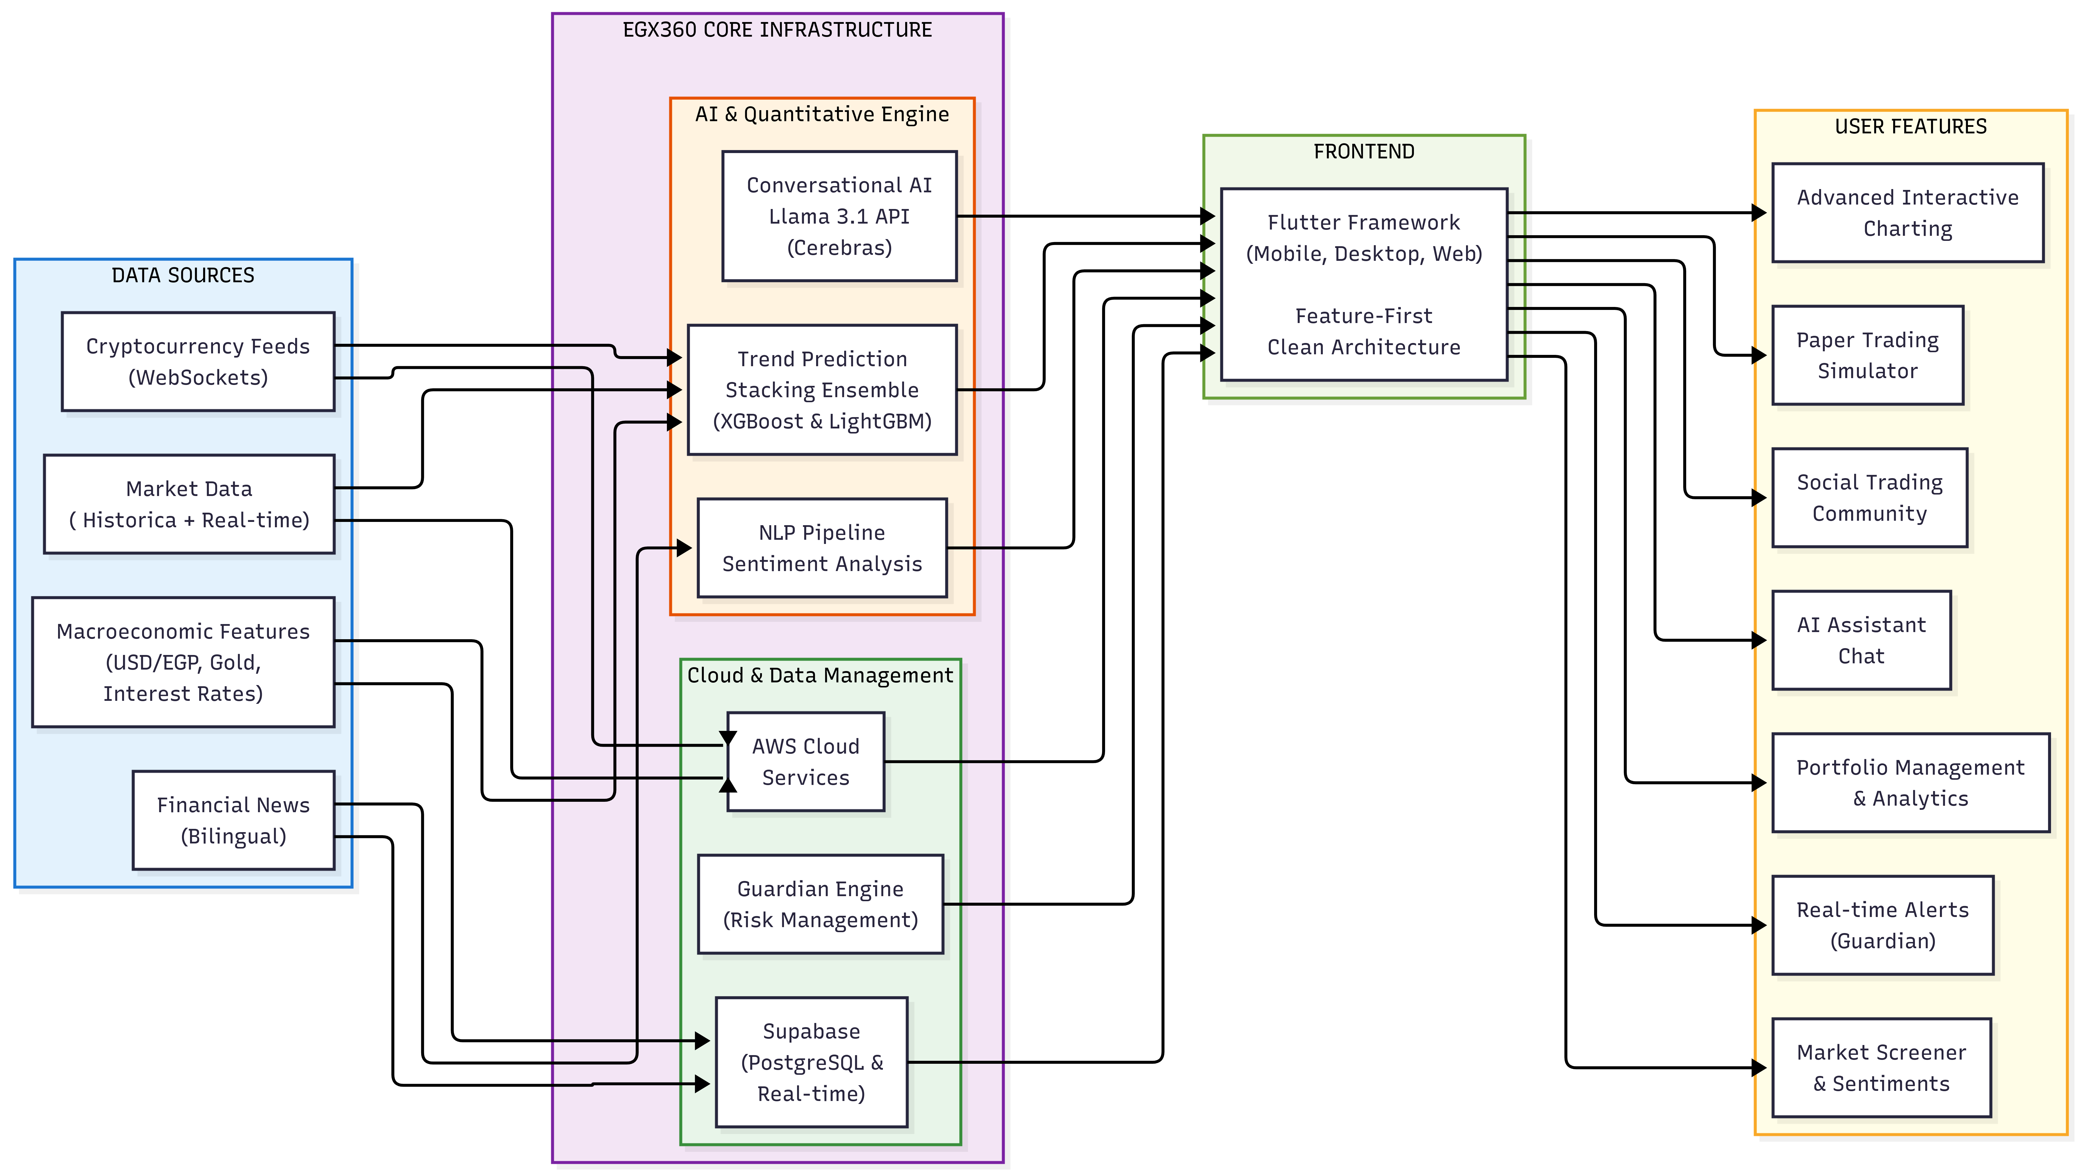

Figure 1.1: High-level Concept of the EGX 360 Ecosystem

Problem Statement
Despite the availability of market data, independent retail investors in Egypt face significant barriers that hinder effective decision-making:
- Data Fragmentation and Complexity: Financial news, technical indicators, and macroeconomic data are often scattered across disparate sources, leading to information overload and analysis paralysis.
- Market Noise in EGX30: The Egyptian market is characterized by high volatility and "noise," where traditional analysis methods often fail to distinguish between random fluctuations and significant trend shifts.
- Lack of Integrated Intelligent Tools: There is a notable absence of local platforms that combine real-time sentiment analysis, AI-driven conversational guidance, and automated risk management in a single accessible interface.

Objectives
The primary goal of this project is to build a robust, production-grade financial intelligence platform that bridges the gap between complex data and individual investors. The specific objectives include:
- Multimodal Quantitative Forecasting: Developing a sophisticated predictive engine using a Stacking Ensemble architecture (XGBoost and LightGBM). This objective extends beyond price history to include the integration of macroeconomic features (USD/EGP rates, gold prices, interest rates) and bilingual NLP sentiment analysis (Arabic and English) to achieve high classification accuracy and market alpha.
- Production-Grade Software Architecture: Engineering a high-performance, cross-platform application using the Flutter framework. A key objective is implementing a "Feature-First Clean Architecture" to ensure system scalability, maintainability, and a seamless user experience across Web, Android, and Desktop environments.

- Autonomous Data Orchestration: Establishing a resilient backend infrastructure on AWS and Supabase. This includes building autonomous data
scrapers for the Egyptian Exchange (EGX) and real-time WebSocket streams for cryptocurrency markets to ensure zero-latency data availability.
- Intelligent Investor Ecosystem: Integrating advanced AI services, including a real-time financial chatbot integrating the Llama 3.1 model via the Cerebras API for contextual market support. Additionally, the project aims to deploy a "Guardian Engine" for automated risk management and a real-time social community to foster interactive trading.
- Risk-Free Financial Simulation: Creating a high-fidelity "Paper Trading" environment that allows users to test strategies using real market data without financial risk, supported by automated portfolio analytics and performance tracking.

Project Scope
The scope of EGX 360 is defined by the following technical and functional boundaries:
- Target Markets: Focuses primarily on the Egyptian Stock Exchange (EGX30 and EGX70 indices) and major Cryptocurrency pairs (e.g., BTC/USD).
- Data Horizon: Utilizes over 28 years of historical EGX data, supplemented by real-time macroeconomic features such as USD/EGP exchange rates, gold prices, and national interest rates.
- Technological Infrastructure: Deployment on AWS cloud infrastructure, utilizing Supabase for secure backend management and real-time data streaming.
- Methodology: Implementation of "Feature-First Clean Architecture" to ensure system scalability and maintainability.

CHAPTER 2

LITERATURE REVIEW

LITERATURE REVIEW
This chapter reviews the evolution of financial prediction methodologies, from traditional statistical models to advanced Machine Learning (ML) and Deep Learning (DL) architectures. It analyzes the limitations of raw price prediction in emerging markets and highlights the gap in Arabic sentiment analysis. Finally, it establishes the rationale for the predictive architecture and risk management strategies employed in the EGX360 ecosystem.

Financial Prediction Methods Overview
Financial time series prediction has evolved from traditional statistical models (ARIMA) to DL architectures like LSTM and GRU, which effectively model sequential dependencies in developed markets. However, a primary flaw in many studies is attempting to predict raw daily closing prices. Raw price movements in highly volatile emerging markets approximate a random walk and are saturated with noise. A landmark 2025 study examining 55 global stock markets, including the EGX30, demonstrated that ML algorithms using only technical indicators achieve an average accuracy of ~51%—barely exceeding random chance.
To overcome this "accuracy ceiling," recent literature advocates for a paradigm shift toward Ensemble Learning and Target Engineering. Predicting smoothed trend direction (e.g., EMA direction) rather than raw prices effectively filters out high-frequency noise. Consequently, contemporary research indicates that breaking the 51% accuracy barrier requires robust Stacking Ensembles integrated with external macroeconomic indicators.

Table 2.1: Comparison of Recent ML/DL Financial Prediction Models

Study | Journal / Rank | Model Architecture | Accuracy / Metric | Target Market
Livieris et al. (2025) | Springer - Q1 | SVM, ANN, LSTM, GB | ~51% | 55 Global Markets
Park et al. (2024) | MDPI Electronics - Q2 | LSTM vs. GRU | ~65% | NASDAQ
Chaudhari et al. (2025) | ScienceDirect - Q2 | Ensemble + Sentiment | ~72% | BSE/NSE India
Springer Nature (2025) | Future Business J. - Q1 | Bi-LSTM, RF, ARIMA | N/A | EGX (5 stocks)
EGX360 (This Work) | - | XGBoost + LightGBM Stack | 90% | EGX30 (1998-2026)

Sentiment Analysis and NLP in Finance
The integration of Natural Language Processing (NLP) has transformed how markets process qualitative information. While advanced models like FinBERT successfully quantify market mood from English news streams, a critical research gap exists in Arabic-language sentiment analysis for the Egyptian market. Emerging markets suffer from a severe scarcity of structured Arabic financial datasets, and Egyptian financial discourse is often saturated with localized slang and specific economic terminologies that traditional NLP pipelines cannot interpret.
To bridge this gap, EGX360 implements a bilingual sentiment pipeline utilizing Large Language Models (LLMs). By leveraging the Llama 3.1 API, the system overcomes the lack of specialized Arabic financial lexicons through deep contextual understanding. Integrating these high-fidelity sentiment signals into the Stacking Ensemble ensures that the system captures vital localized qualitative drivers that traditional price-only models ignore.

Emerging Markets vs. Developed Markets
Unlike developed markets (e.g., S&P 500) which are characterized by high information efficiency, emerging markets like the Egyptian Exchange (EGX) exhibit significant heteroskedasticity, a low Signal-to-Noise Ratio (SNR), and "fat-tailed" return distributions. A major differentiator is their extreme sensitivity to external macroeconomic shocks. Egypt’s import-dependent economy means that equity prices are inextricably linked to the USD/EGP exchange rate, gold prices, and Central Bank of Egypt (CBE) interest rate decisions.
EGX360 addresses this gap by treating the Egyptian market as a unique ecosystem. By integrating these Egypt-specific macroeconomic features, the model captures the fundamental "fuel" that drives local market cycles. This multi-dimensional approach allows the Stacking Ensemble to achieve superior predictive accuracy (85.22%) by identifying economic regimes that traditional technical models overlook.

Table 2.2: Comparison of Statistical and Fundamental Properties
Market Property | Developed Markets (e.g., S&P 500) | Emerging Markets (e.g., EGX30)
Volatility | Generally lower and more predictable. | High and prone to sudden clustering.
Efficiency | High informational efficiency. | Low Signal-to-Noise Ratio (SNR).
Return Distribution | Approximates Normal Distribution. | Leptokurtic with "Fat Tails".
Main Drivers | Corporate earnings & Global growth. | Macro shocks, Currency rates & Inflation.
Participant Behavior | Dominated by Institutional investors. | High impact of Retail (emotional) investors.

Risk Management in Automated Trading
In high-volatility environments like the EGX, over-reliance on raw ML predictions without a robust safety net can lead to significant capital drawdown. A significant gap in current automated platforms is the lack of "contextual risk awareness," relying heavily on static, fixed-percentage exits. Prior studies highlight that a high "Down Recall"—the ability to correctly identify declining sessions—is more vital for capital preservation than overall accuracy.
EGX360 addresses these challenges through a multi-layered "Guardian Engine" that implements dynamic risk thresholds. A key innovation is the integration of the Llama 3.1 financial assistant, which analyzes the risk implications of real-time news to provide optimal decision-making support. Additionally, a high-fidelity "Paper Trading" simulator allows investors to test strategies against 28 years of historical market cycles (1998–2026) before risking actual capital, ensuring EGX360 functions as a secure financial ecosystem.

CHAPTER 3

SYSTEM DESIGN & ARCHITECTURE

SYSTEM DESIGN & ARCHITECTURE

Requirements (Functional & Non-Functional)
To ensure the EGX360 ecosystem effectively addresses the complexities of the Egyptian Exchange and delivers a seamless user experience, the system requirements are clearly defined into functional capabilities and non-functional constraints.

3.1.1. Functional Requirements
These requirements define the core services and complex automated tasks the system must execute:
Feature | Description
Multi-Source Ingestion | Automated scraping via reverse-engineered EGX APIs, Binance feeds, and macro scripts.
Bilingual NLP Sentiment | Arabic/English sentiment analysis of financial narratives and news using Llama 3.1.
Technical & Macro Analytics | Real-time technical indicators (RSI, EMA) and macroeconomic driver integration.
Intelligent Forecasting | High-fidelity trend prediction (Up/Down) via optimized Stacking Ensembles.
Virtual Trading Economy | Simulated trading with encrypted virtual wallets and real-time P&L tracking.
Financial RAG Assistant | Conversational AI using RAG for contextual market insights and portfolio data.
Social Ecosystem | Real-time community feed for sharing market insights and sentiment tags.
Guardian Risk Engine | Proactive risk management with automated alerts for volatility and price-drop events.

3.1.2. Non-Functional Requirements
These requirements define the quality attributes, performance goals, and security measures of the system:
Category | Requirement | Specification
Security | Data Privacy | Implementation of Row Level Security (RLS) within the database and full encryption for all sensitive transaction data in the virtual wallet.
Scalability | Performance | Distributed cloud infrastructure hosted on AWS and Supabase capable of handling concurrent requests and high-frequency scraping with minimal latency.
Usability | Cross-Platform | Providing a responsive and unified user experience across Android, Web, and Desktop platforms using a single Flutter codebase.
Reliability | Fault Tolerance | Ensuring 24/7 operation for Python-based daemons with automated mechanisms to handle network failures or external API rate limits.

3.1.3. System Use Case Diagram
The EGX360 Use Case Diagram defines the primary interactions between the users and the system's intelligent background services:
- Retail Investor Operations: Managing profiles, viewing real-time market data/indicators, executing paper trades, and engaging in the social community feed.
- AI & Automation Daemons: Handling autonomous scraping, bilingual sentiment analysis (Llama 3.1), and generating market trend forecasts via Stacking Ensembles.
- Intelligent Risk & Assistance: Managing alert thresholds via the Guardian Engine and interacting with the RAG-powered AI Financial Assistant for contextual support.

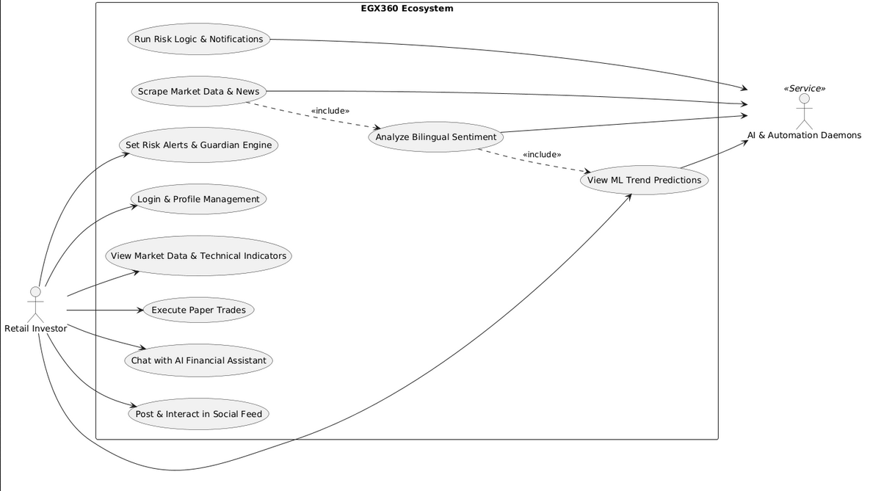

Figure 3.1.3: Use Cases

High-Level Architecture Diagram
The EGX360 ecosystem utilizes a distributed, 4-tier architecture designed to bridge real-time financial data with machine learning intelligence.
- Raw Data Sources: Ingesting real-time market data via reverse-engineered EGX endpoints, Binance APIs, and macroeconomic scripts.
- Intelligence & Automation (AWS EC2): Hosting the Python-based daemons for bilingual sentiment analysis (Llama 3.1) and trend forecasting using Stacking Ensembles (XGBoost/LightGBM).
- Persistence & Security (Supabase): Managing centralized PostgreSQL storage with Row Level Security (RLS) for data privacy and real-time database synchronization.
- Delivery & Presentation (Flutter): Distributing real-time financial insights and FCM-based alerts to the multi-platform application developed using Flutter.



Figure 3.2.:

Database Schema and Conceptual Data Model
The EGX360 database utilizes a relational PostgreSQL schema hosted on Supabase. It is architected to support high-frequency market ingestion and real-time social interactions while maintaining strict data isolation via Row Level Security (RLS).
- Identity & Social Domain: Manages user profiles and bilingual community interactions, including posts, nested comments, and a multi-directional follow system.
- Market Intelligence Domain: Centered around the Stock entity, this domain links real-time price action with AI Predictions and automated news sentiment analysis.
- Virtual Trading & Risk Domain: Handles the paper-trading engine, managing virtual wallets, real-time portfolio holdings, and user-defined protection rules via the Guardian Engine.
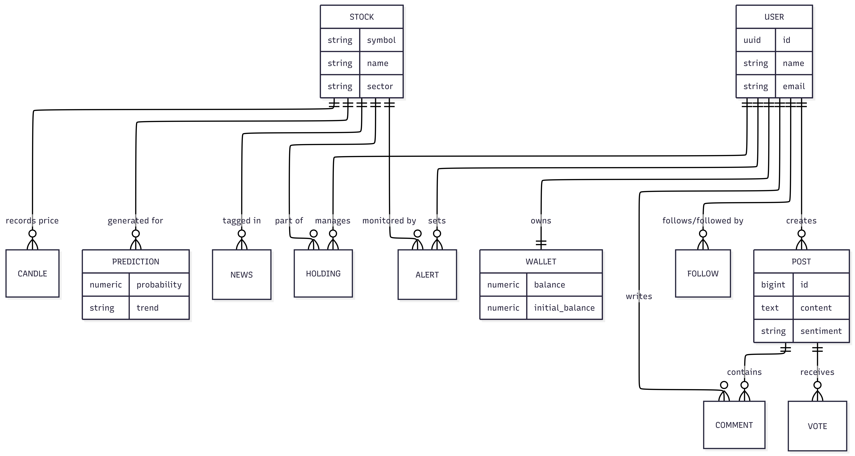
Figure 3.3: Conceptual Entity-Relationship Diagram (ERD)

Sequence Diagrams

3.4.1. Autonomous News Ingestion & Cerebras AI Analysis
This sequence illustrates the integrated pipeline for financial data ingestion, hybrid sentiment analysis (BERT/Llama 3.1), and market trend forecasting using Stacking Ensembles.
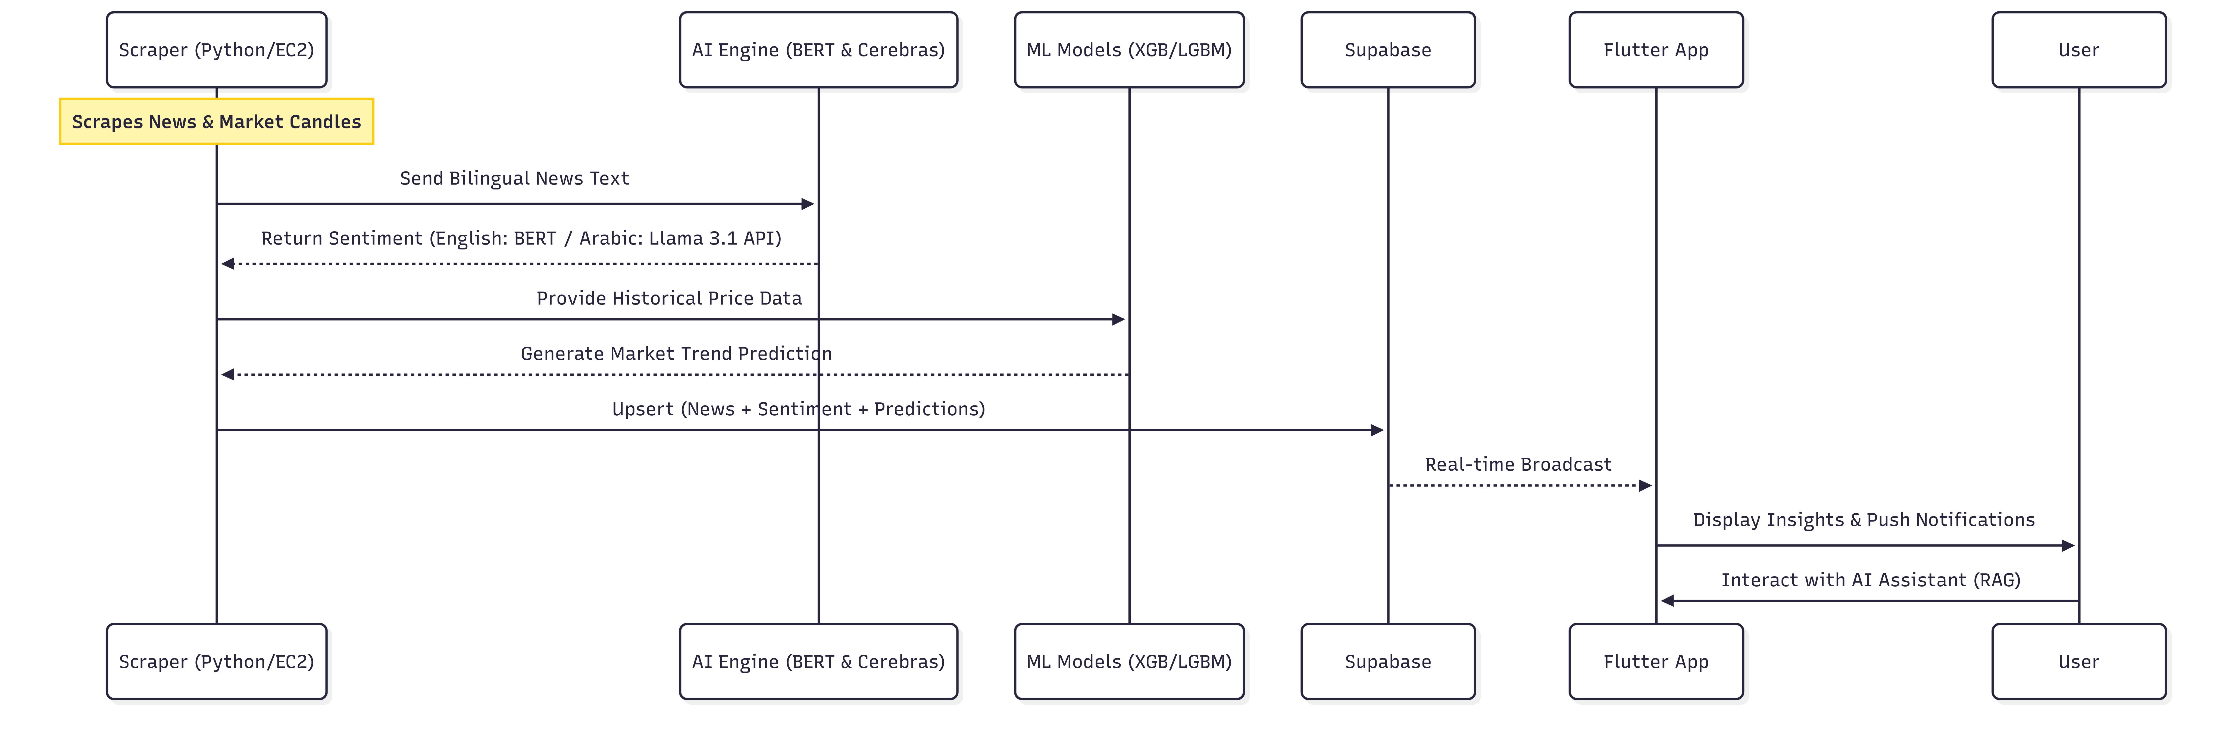

Figure 3.3: Conceptual Entity-Relationship Diagram (ERD)

3.4.2. Guardian Engine & Risk Management Sequence
This sequence details the automated risk management flow where the background engine monitors real-time portfolio health against user-defined protection rules (e.g., stop-loss thresholds) and dispatches real-time alerts.
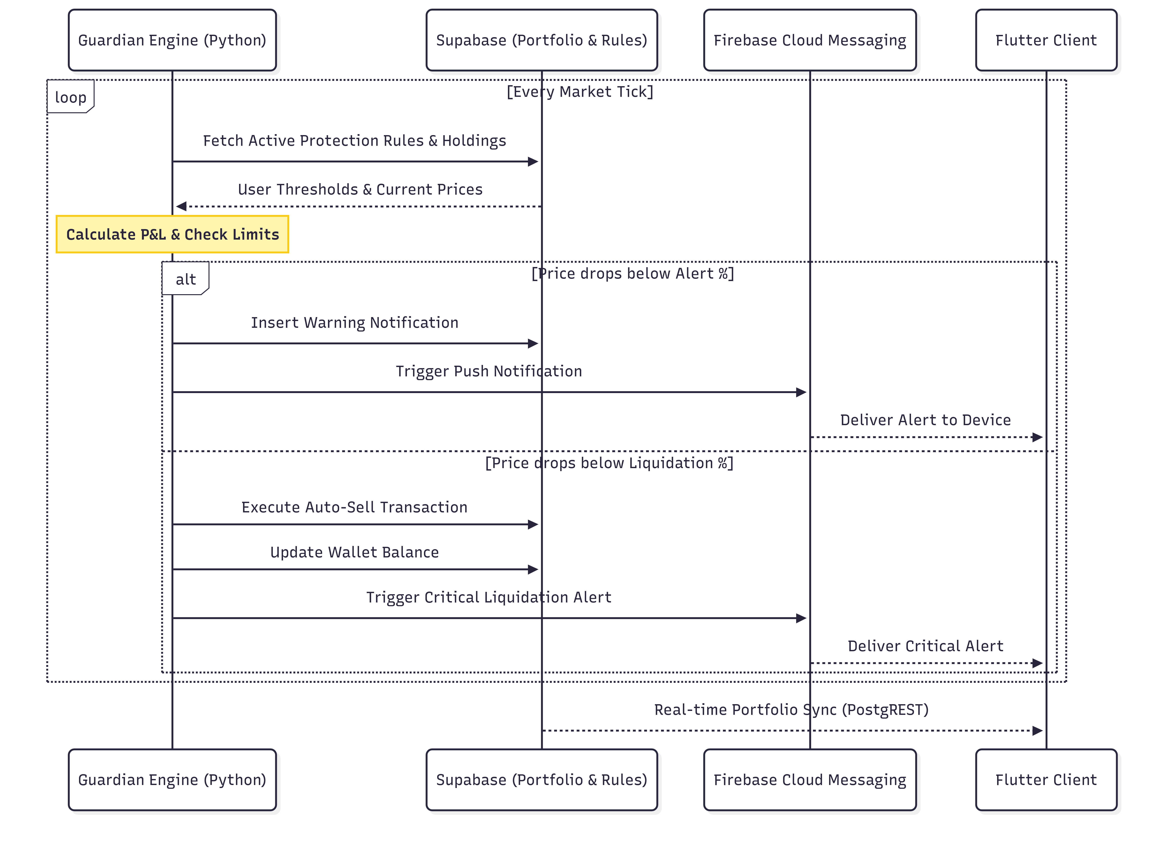

Figure 3.3: Conceptual Entity-Relationship Diagram (ERD)

3.4.3. Virtual Trade Execution Sequence
This sequence illustrates the transactional logic of the paper-trading engine. It details how the Flutter client interacts with Supabase Remote Procedure Calls (RPCs) to validate wallet balances, calculate average holding prices, and securely record transactions.


Figure 3.3: Conceptual Entity-Relationship Diagram (ERD)

Technology Stack Selection
The EGX360 ecosystem utilizes a modern, decoupled technology stack selected for its scalability, real-time capabilities, and support for complex Arabic NLP and financial modeling.

Category | Technology | Reason for Selection
Multi-Platform App | Flutter & Dart | Enables a unified, high-performance experience across Android, Web, and Desktop from a single codebase.
Backend & Database | Supabase (PostgreSQL) | Provides real-time synchronization, centralized authentication, and Row Level Security (RLS) for sensitive financial data.
Language | Python | The industry standard for financial scraping, data science, and integrating advanced ML models.
Cloud Hosting | AWS (EC2) | Scalable infrastructure required to host persistent Python daemons for market scraping and AI inference.
AI (Forecasting) | XGBoost / LightGBM | Optimized Stacking Ensembles designed for high-fidelity tabular data trend prediction.
AI (NLP & RAG) | Llama 3.1 API / BERT | Advanced bilingual support (Arabic/English) for sentiment analysis and contextual financial assistance.
DevOps & Deployment | Docker | Utilized to containerize the Python daemons, ensuring consistency between development and production environments on AWS.

CHAPTER (4)

Title of Chapter 4

Title of Chapter 4

survey

CHAPTER (5)

Title of Chapter 5

Title of Chapter 5

survey

CHAPTER (6)

Title of Chapter 6

Title of Chapter 6

survey

CHAPTER (7)

Conclusions

Conclusions

Survey

References

References

